How to connect Dust Collector System
1, collect the dust hood (red part) into the dust pipe (blue part)
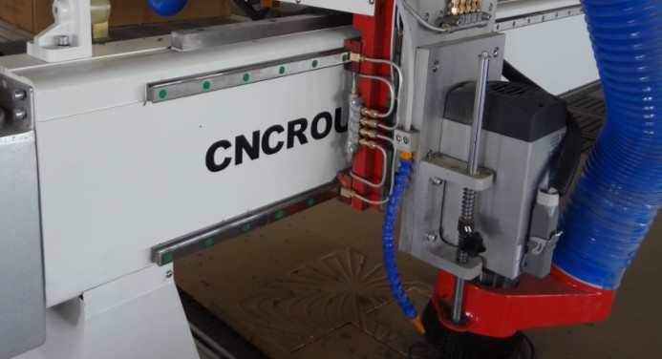
2, find the dust holder (part 01) in the package, connect it into your machine here:
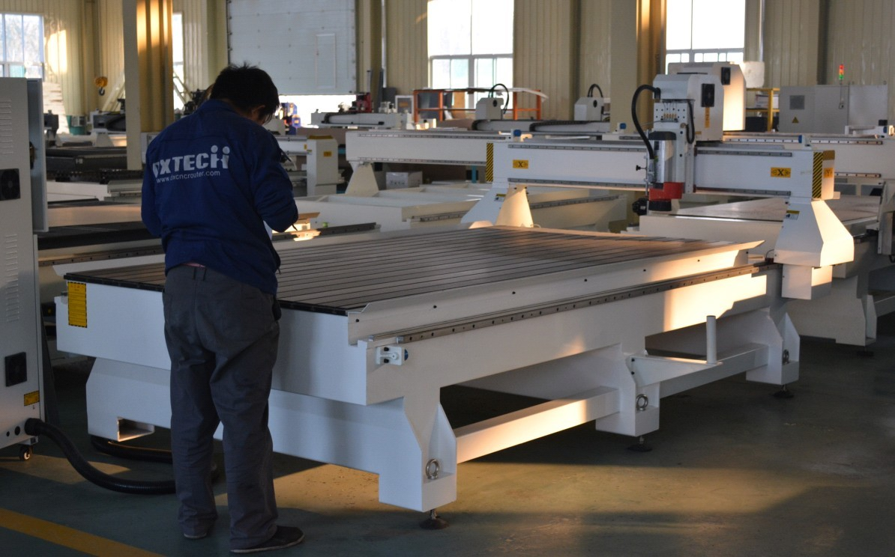
Dust holder part 01: find it in the package then connect it into your machine
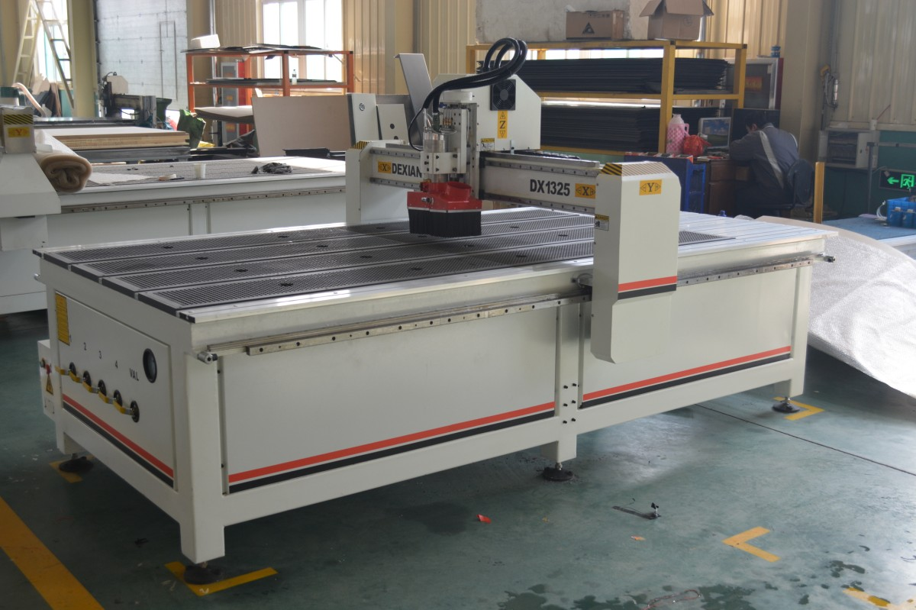
Connect here
3, then connect the dust holder (part 02)
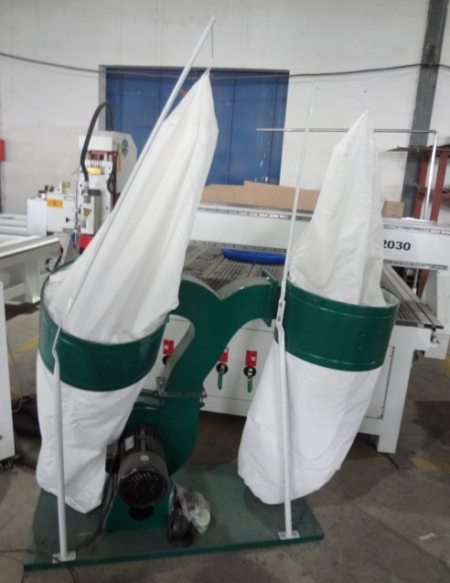
Dust holder part 02 : connect it into the dust holder part 01
4, For your 1325P cnc machine, you only need to connect the wire of the dust collector into the power supply switch, then can get the power, for getting the power dust collector system and DX-1325P cnc machine is separately. But the work is together, when you are using cnc route , dust collector goes on automatically.
You can see the video- making door 